Railgo Construction Inc.
Customer Success Story
Remmers Consulting Saves a Billion-Dollar Contract
and Helps Railgo win Preferred Bidder Status
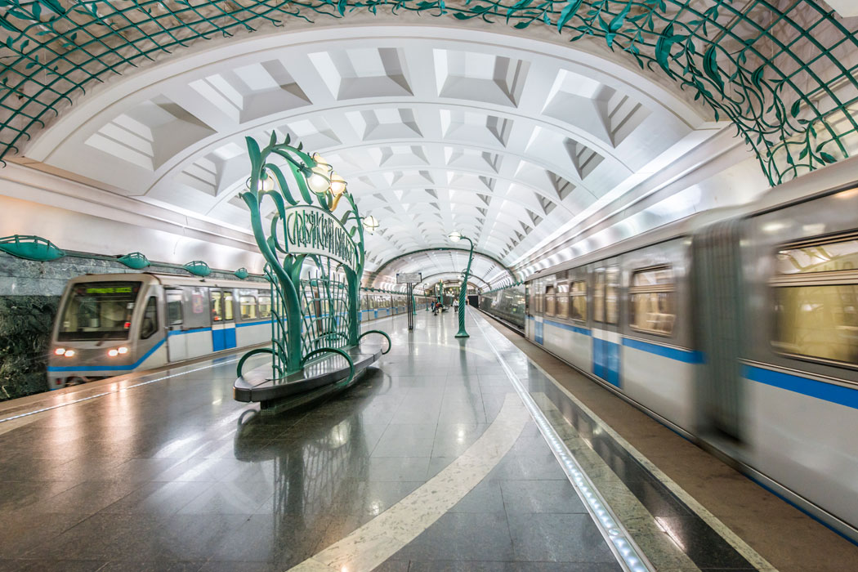

Railgo Construction Inc.

- Full-service, multi-national
rail and transit system designer and contractor
- Specialist in EPC or fixed-price new construction or system upgrade projects
- Hired Remmers Consulting
in 2015

BACKGROUND

Major Transit, one of the world’s biggest transit systems with well over a dozen lines and more than 200 stations, had commissioned RailGo to build a new transit line. But this line came with a challenge: Major had become increasingly dissatisfied with the signalling system then being used on its lines. Breakdowns were becoming less than abnormal occurrences, and there had even been a collision. Fortunately, no one had been hurt. But Major knew that worse would follow if they did nothing. So, they put together a wish list for a new signalling system with vastly improved capabilities. But the new line’s signals would have to interface perfectly with those of the old system.

This meant that a junction box would be an essential component of the new system. But Major hadn’t commissioned RailGo to build the junction box that would enable the old and new signalling systems to communicate with one another. Since they wanted to control that product, they had commissioned another subcontractor to produce it.
THE CHALLENGE

Two weeks before the final deadline, however, RailGo’s Project Manager got a call that stunned him.

“I picked up the phone,” Mark Perry said, “and it was Major’s Project Sponsor. He told me that the consultant designing the junction box had been killed in a car accident and he asked if we could take over the project? While our part of the contract was completed, the new line couldn’t operate without the junction box. And since the consultant’s wife, who doubled as his secretary, had been in a coma since the crash, nobody had the password to his thoroughly secured computer system. Which meant that Major’s sponsor was not only asking us to come up with a component in two weeks that their consultant hadn’t delivered in a year, he was telling us that we would have to start the project from the very beginning.

“Unfortunately, we didn’t have anyone on staff who could be freed up to do the project in the available timeframe. Instead, we needed to find a consultant who could quickly design and deliver a complex new
component. Finding a consultant who could deliver a project like that in such a short time frame is like trying to find a needle in a haystack.”
Railgo Construction Inc.

THE SOLUTION

When Perry asked around for a suitable RailGo engineer, he discovered that a new consultant had just opened his practice. As he tells the story, “One of our people I talked to had a brother-in-law who was an innovative signals engineer who had delivered high-quality work for many world-class systems and was noted for his ability to work quickly. And he also knew that John had just set up shop on his own that week. If I hadn’t mentioned the situation to Brad, we might not have known John was available because he lives in another country.”

So Perry called John Remmers.

Because John had worked on an earlier Major project for a previous employer, he knew the people, he knew the design standards, and most important, he knew Major’s old signalling system inside out. Consequently, he was able to hit the ground running.

Within two days, he had an approach worked out, and by the eighth day, he had delivered the junction box for testing. After two days of tests, Mark Perry knew that the junction box interfaced perfectly with both signalling systems. And that meant that the new line would start on schedule.

THE RESULTS

Saving the Deadline

“By providing the new junction box within the deadline, Remmers enabled RailGo to open Major’s latest line on schedule winning plaudits from Major for avoiding a public relations disaster,” says Mark Perry.
“John Remmers not only saved the deadline, he delivered improved signalling efficiencies, extended system lifecycles and won us preferred bidder status and first contracts from two new customers.”
Mark Perry, Senior Project Manager, Railgo Construction Inc.

Improved Signalling Efficiencies

While designing the junction box Remmers also devised a new way of
increasing signalling efficiencies. According to Perry, “by using an improved optimization technique
and genetic algorithms in place of conventional search methods, John delivered a 20% capacity increase on the new line instead of the 10% we had been contracted to deliver.”

Extended System Lifecycles

“Also, John figured out a way to integrate the new line’s signalling efficiencies with the existing systems on the two older lines that connected with the new one. This increased signalling capacity on the older lines by 10%, and it extended the service life of these lines’ signalling systems by an additional twenty years. What’s even more important, those two connecting lines had the oldest signalling in the entire system. But now, with the new efficiencies John delivered, for the first time, Major can use an automatic train control system (ATC) throughout the entire system, something they’ve wanted to do for decades.”

“And since John was very careful to deliver an open-ended design for the junction box, we will be able to deliver that ATC system almost effortlessly, not to mention incorporating many future improvements into the system without any trouble at all. Which means that we’ll be able to stay right on top of Major’s needs. So, as you can imagine, Major is very happy with us right now.”

Preferred Bidder Status

And, as Mark Perry notes, because “Remmers had provided the junction box as a RailGo subcontractor, RailGo became the preferred bidder for any of Major’s new line construction contracts. And from what we know of their planning, we anticipate that there will be several projects running into the billions of dollars commissioned in the next twenty years.”
New Market Penetration

Perry concludes, “Last but not least, John’s work has been noticed by other transit and rail operators, who were also considering signalling upgrades on their
new construction. Since the new Major line opened, six operators have asked us to bid on their projects. Four of these are systems that had never worked with us
before. And because of John’s junction box, we were not only asked to quote; we also won two of those projects. That’s a two-billion-dollar revenue boost, right there.”

“John made all that happen for us,” Perry concludes, “He is innovative, careful, fast, yet thorough, extremely professional, and very easy to work with. He’s got a position with us waiting for him anytime he wants it, but he wants to stay on his own.”

Contact Information

To learn how Remmers Consulting can help your rail or transit system surmount its signalling challenges, visit us at:
RemmersElectricalEngineering.ca

